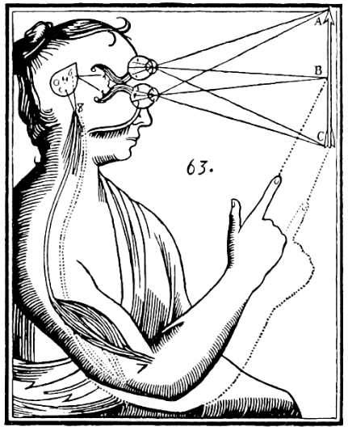
These courses fulfill the IR Research Methods requirement.

ANTH 1940 | Ethnographic Research Methods
ANTH 1151 | Ethnographies of the Muslim Middle East
APMA 0650 | Essential Statistics
APMA 1650 | Statistical Inference
CLPS 0900 | Quantitative Methods in Psychology
ECON 1620 | Introduction to Econometrics
ECON 1630 | Econometrics I
EDUC 1100 | Intro to Qualitative Research Methods
EDUC 1110 | Intro Statistics for Education Research and Policy Analysis
HIST 1972E | Word of Mouth: Orality and Memory in Historiography and documentary Film
PHP 1320 | Survey Research in Health Care
POLS 0500 | Foundations of Political Analysis
POLS 1600 | Political Research Methods
SOC 1020 | Methods of Social Research
SOC 1050 | Methods of Research in Organizations
SOC 1100 | Intro Statistics For Social Research

